UNIVERSITY OF ENGINEERING AND TECHNOLOGY MARDAN


Data Mining Lab: 04
Muhammad Ismail
23MDBCS415
Department: CS (Data Science)
6th Semester

Upload Dataset
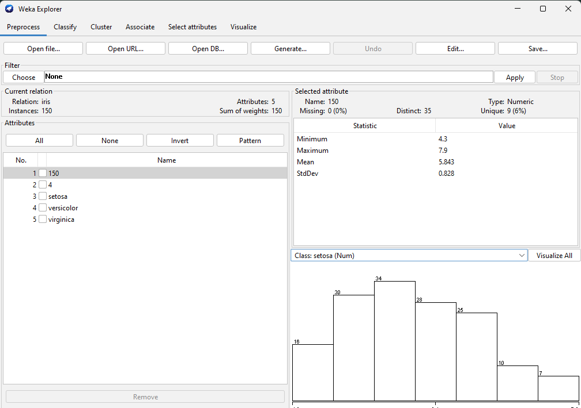
Perform preprocessing: replace missing values
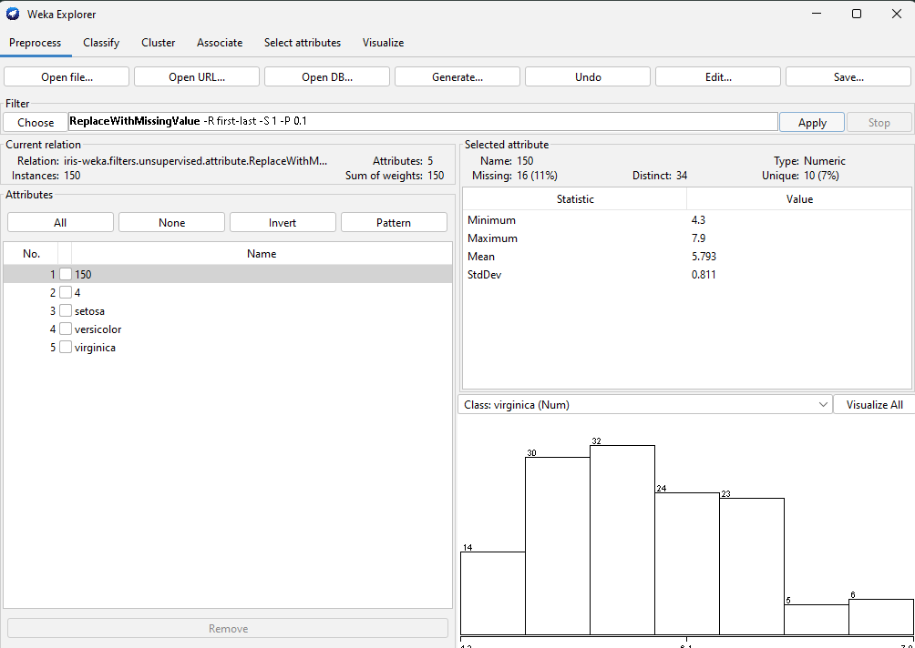
irrelevant attributes
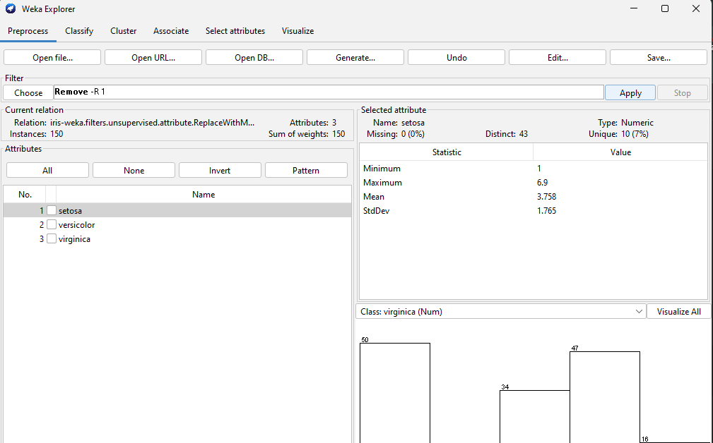Apply normalization or standardization.
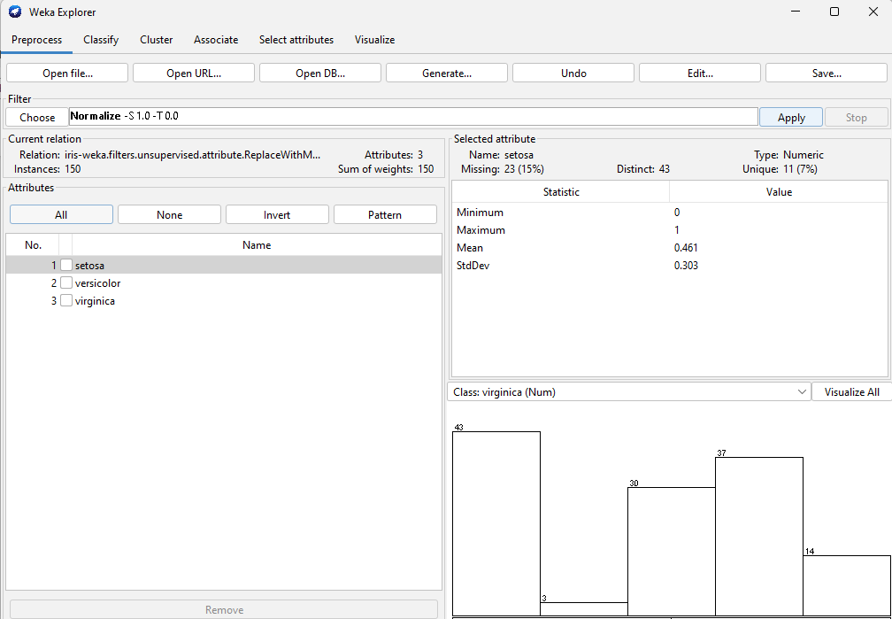
Feature Selection using InfoGain
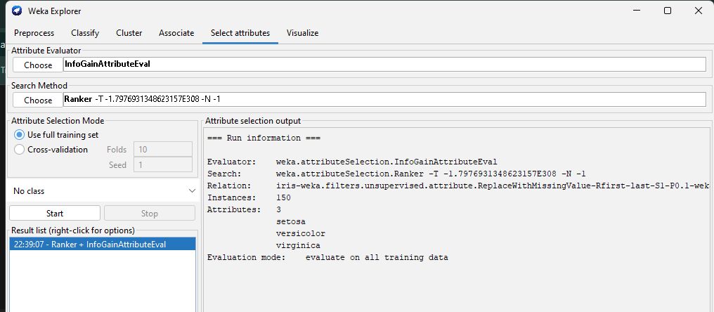
Apply PCA (Dimensionality Reduction)
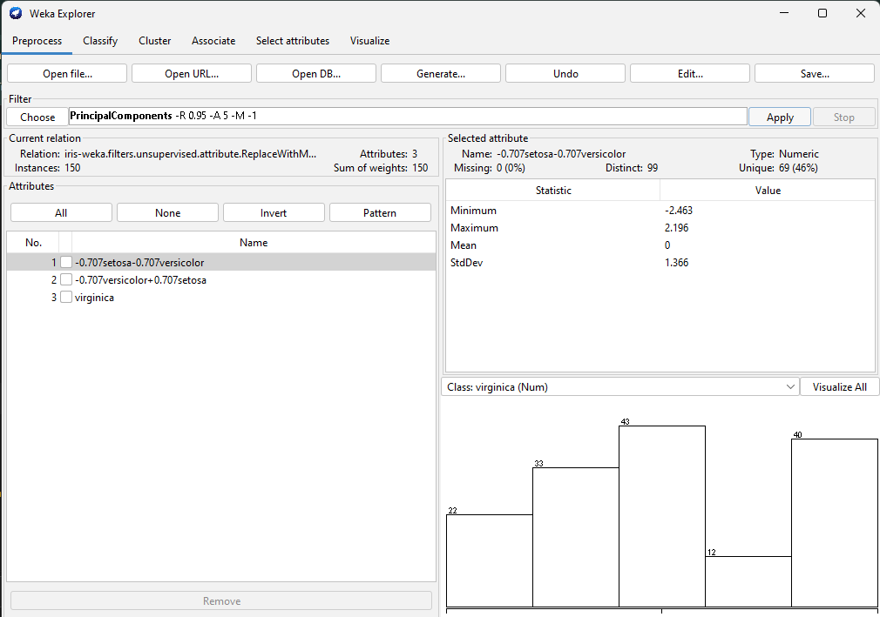

Optional
